**Core Java Assignment 4**

**Assignment on Exception handling**

**1.**

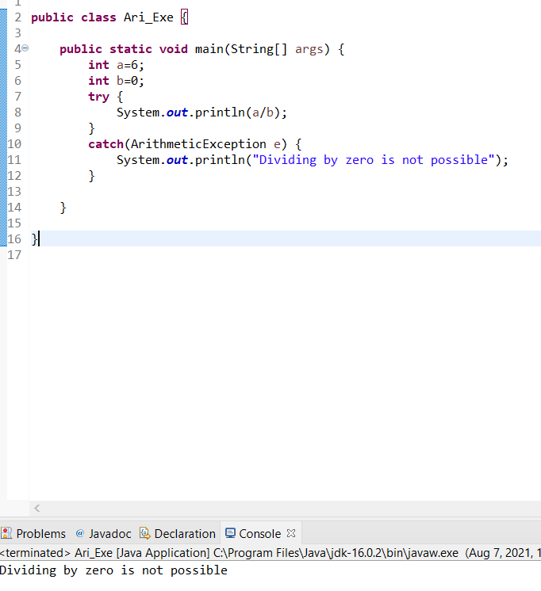

**2.**

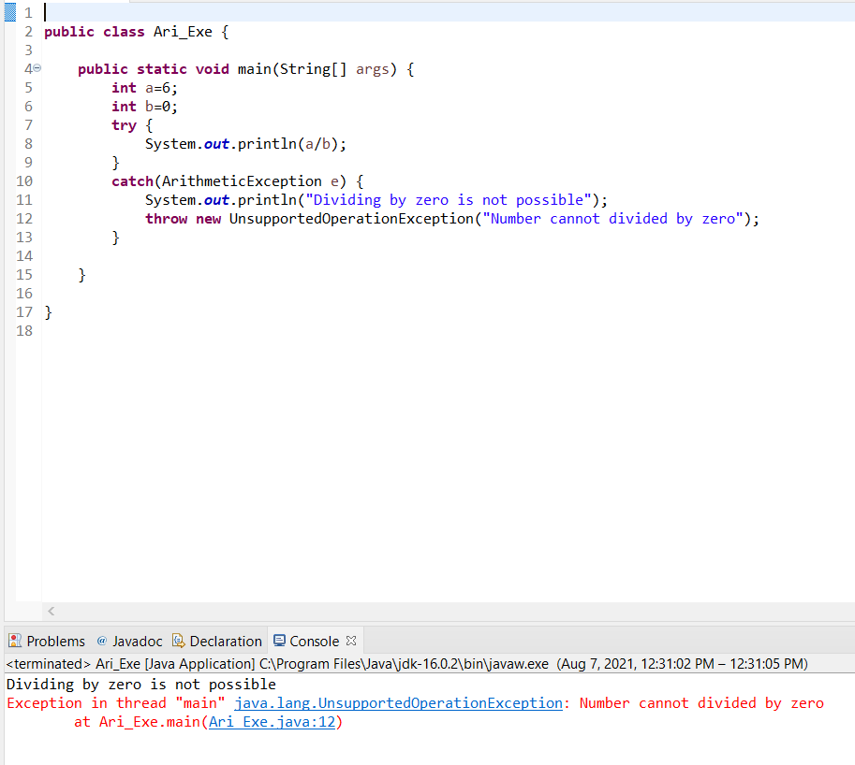

**3.**

**public** **class** Saving_Account {

**long** id;

**static** **double** *balance*;

**static** **double** *withdraw*;

**static** **double** *deposit*;

**public** Saving_Account(**long** id, **double** balance, **double** withdraw, **double** deposit) {

**this**.id=id;

**this**.*balance*=balance;

**this**.*withdraw*=withdraw;

**this**.*deposit*=deposit;

}

**public** **long** getId() {

**return** id;

}

**public** **void** setId(**long** id) {

**this**.id = id;

}

**public** **static** **double** getBalance() **throws** InsufficientBalanceException{

**if**(*balance*>*withdraw*) {

*balance*=*balance*-*withdraw*+*deposit*;

**return** *balance*;

}

**if**(*withdraw*<0) {

**throw** **new** InsufficientBalanceException("withdraw is less than zero"+*balance*);

}

**else** {

**throw** **new** InsufficientBalanceException("Insufficient balance"+*balance*);

}

}

**public** **double** getWithdraw() {

**return** *withdraw*;

}

**public** **void** setWithdraw(**double** withdraw) {

**this**.*withdraw*=withdraw;

}

**public** **double** getDeposit() {

**return** *deposit*;

}

**public** **void** setDeposit(**double** deposit) {

**this**.*deposit*=deposit;

}

